**Polarization converter based on a rectangular waveGuide with a stepped longitudinal conducting plate**

***S.І. Piltyay, V.V. Shuliak, A.V. Bulashenko,***

***O.V. Bykovskyi, O.A. Kornieva, A.P. Saranchuk***

*Igor Sikorsky Kyiv Polytechnic Institute, Kyiv, Ukraine*

crosspolar@ukr.net, iamnerones@gmail.com, a.bulashenko@kpi.ua,

annasaranchuk01@gmail.com, olyakorneva09@gmail.com, sandro66@ukr.net

Modern radar and satellite systems use polarization signal processing. It is carried out by polarization converting devices that convert the types of polarization. Then polarized devices appeared based on a square waveguide with diaphragms and pins of different configurations [1-4]. But for a narrow frequency range, polarization devices based on a square waveguide with a metal plate have better characteristics [5-7]. Septum polarizer which is the essential passive component of receiver constitutes a simple and compact device for converting linear polarization into circular polarization and vice versa. The aim of the work is to study the main characteristics of the device for converting the polarization of the X-band range.

The three-dimensional model a waveguide polarization conversion device with stepped plate is shown below (Fig. 1).

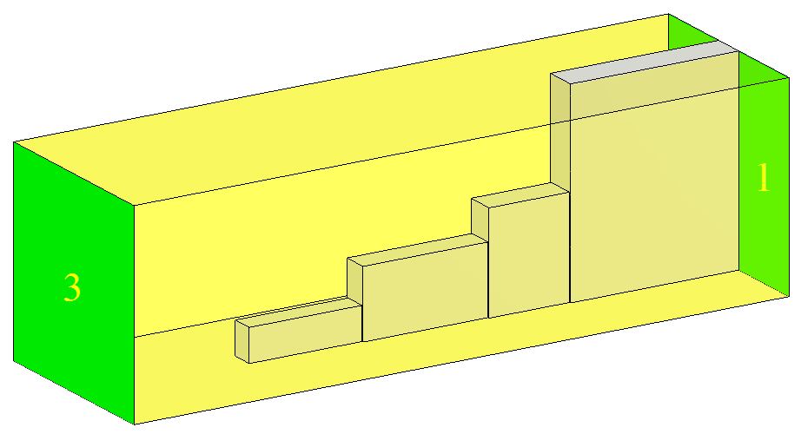

Fig. 1. Three-dimensional model and design of stepped polarizer

This design provides the basic polarization characteristics. The polarizing device is designed on the basis of a rectangular waveguide with a metal plate. The plate is designed in the form of three steps.

Below are the results of the study, namely the dependence of the characteristics on the frequency for our frequency range 7.7 GHz - 8.1 GHz, which were obtained in a specialized program using computer simulation [8, 9]. The main characteristics are differential phase shift, voltage standing wave ratio (VSWR), and crosspolar discrimination (CPD).

Fig. 2 shows the dependence of the differential phase shift of the polarizer in the frequency range 7.7-8.1 GHz. As can be seen, the differential phase shift is equal to 90°±0.9º.

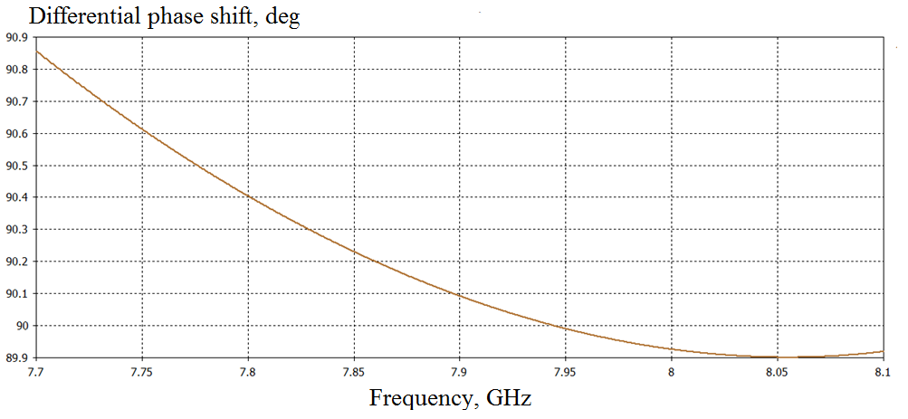

Fig. 2. Dependence of differential phase shift on frequency

Fig. 3 presents the dependence of the VSWR of the developed polarizer for horizontal and vertical polarization. As can be seen, the maximum level of VSWR for both linear polarizations is 1.042.

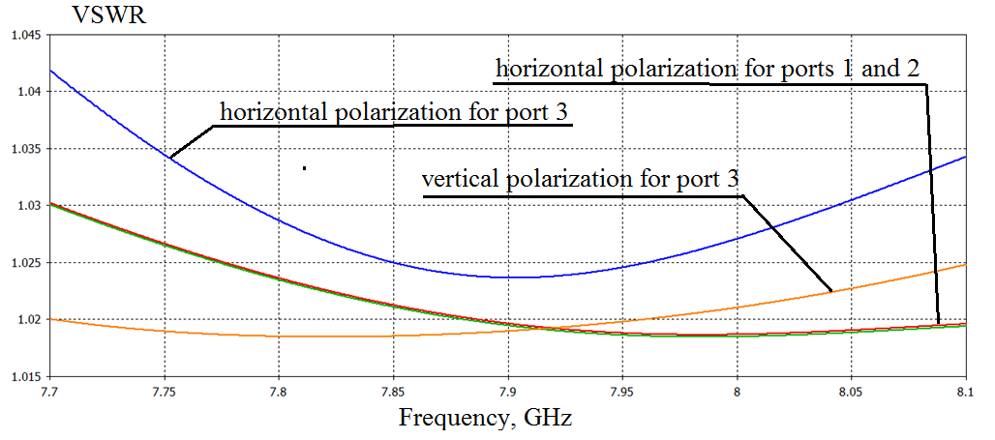

Fig. 3. Dependence of VSWR on frequency for both polarizations

Fig. 4 shows the dependence of the crosspolar discrimination of the polarizer in the frequency range 7.7-8.1 GHz. As can be seen, the CDP does not exceed -42 dB.

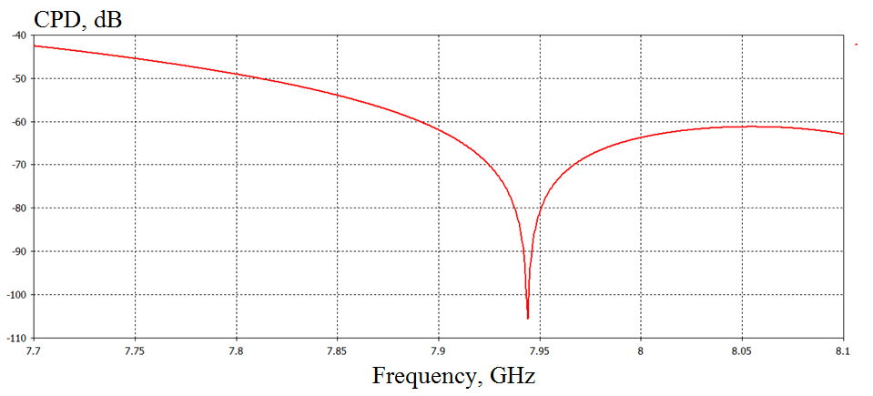

Fig. 4. Dependence of crosspolar discrimination on frequency

Thus, the developed waveguide polarization converter on a rectangular waveguide with a stepped plate has the following characteristics. The range of change of the differential phase shift is 90°±0.9°. The polarizer provides VSWR less than 1.044. CPD is higher than 42 dB.

Referecses

1. Piltyay S. Development and optimization of microwave guide polarizers using equivalent network method / S. Piltyay, A. Bulashenko, V. Shuliak // Journal of Electromagnetic Waves and Applications. – 2021. – Vol. 35, 2021. DOI: 10.1080/09205071.2021.1980913.
2. Bulashenko A.V. Simulation of compact polarizers for satellite telecommunication systems with the account of thickness of irisess / A.V. Bulashenko, S.I. Piltyay, I.V. Demchenko // KPI Science news. – 2021. – Vol. 1. – pp. 7–15. DOI: 10.20535/kpisn.2021.1.231202.
3. Bulashenko A.V. Tunable polarizers for X-band radar and telecommunication systems / A.V. Bulashenko, S.I. Piltyay, Y.I. Kalinichenko, O.V. Bulashenko // KPI Science news. – 2021. – Vol. 2. – pp. 7–15. DOI: 10.20535/kpisn.2021.2.236953.
4. Shuliak V. Modern microwave polarizers and their electromagnetic characteristics / V. Shuliak et al. // IEEE 3rd Ukraine Conference on Electrical and Computer Engineering (UKRCON), Lviv, Ukraine, August 2021, pp. 21–26. **DOI:**[10.1109/UKRCON53503](https://doi.org/10.1109/MCOM.2014.6807944).2021.9575879.
5. Dubrovka F.F. Optimum septum polarizer design for various fractional bandwidths / F.F. Dubrovka, S.I. Piltyay, et al. // Radioelectronics and Communications Systems – 2020. – Vol. 63, no. 1. – pp. 15-23. http://doi.org/[10.3103/І07352720010021.](https://doi.org/10.1109/LMWC.2008.2001005)
6. Dubrovka F. Compact X-band stepped-thickness septum polarizer / F. Dubrovka, S. Piltyay, O. Sushko, et al. // IEEE Ukrainian Microwave Week, Kharkiv, Ukraine, September 2020, pp. 135–138. DOI: 10.1109/UkrMW49653.2020.9252583.
7. Dubrovka F. Circularly polarised X-band H11- and H21-modes antenna feed for monopulse autotracking ground station / F. Dubrovka et al. // IEEE Ukrainian Microwave Week, Kharkiv, Ukraine, September 2020, pp. 196–202. DOI: 10.1109/UkrMW49653.2020.9252600.
8. Al-Amoodi K. A compact substrate integrated waveguide notched-septum polarizer for 5G mobile devices / K. Al-Amoodi, R. Marzavand et al. // IEEE Antennas and Wireless Propagation Letters. – 2020. – Vol. 19, no. 12. pp. 2517–2521, 2021. DOI: 10.1109/LAWP.2020.3038404.
9. Piltyay S.I. Numerical performance of FEM and FDTD methods for the simulation of waveguide polarizers / S. I. Piltyay, A. V. Bulashenko, and Y. Y. Herhil // Visnyk NTUU KPI Seriia – Radiotekhnika Radioaparatobuduvannia, vol. 84, pp. 11–21. March 2021. DOI: 10.20535/RADAP.2021.84.11-21.

Анотація

Представлені результати розробки перетворювача поляризації на прямокутному хвилеводі на металевій пластині із трьома сходинками. Створений прилад працює в Х-діапазоні.

Ключові слова: пластинчатий поляризатор, діафрагма, штир, хвилевод.

Abstract

The results of development of the polarization converter on a rectangular waveguide on a metal plate with three steps are presented. The created device operates in the X-band range.

Keywords: polarization convertor with plate, diaphragm, post, waveguide.